AIM: “RAM Forensics - Capture the volatile memory (RAM) and Analyze using Volatility Workbench/ Volatility Framework 3”
To acquire a Windows RAM image and perform memory forensics using Volatility 3 to examine running processes, process relationships, and network connection artefacts.

Procedure
Step 1: Capture RAM Using Magnet RAM Capture
Magnet RAM Capture v1.2.0 was used to acquire a snapshot of the system's volatile memory. RAM acquisition preserves information about the running system that may be lost when the computer is shut down.
- Open Magnet RAM Capture v1.2.0.
- Select the destination folder for saving the memory image.
- Specify the output filename as ramdump.raw.
- Start the RAM capture and wait for the acquisition to finish.
- Verify that the application displays a successful completion message and that the .raw file is created.
Output file:
ramdump.raw
Capture size: Approximately 10,232 MB, as displayed by Magnet RAM Capture.
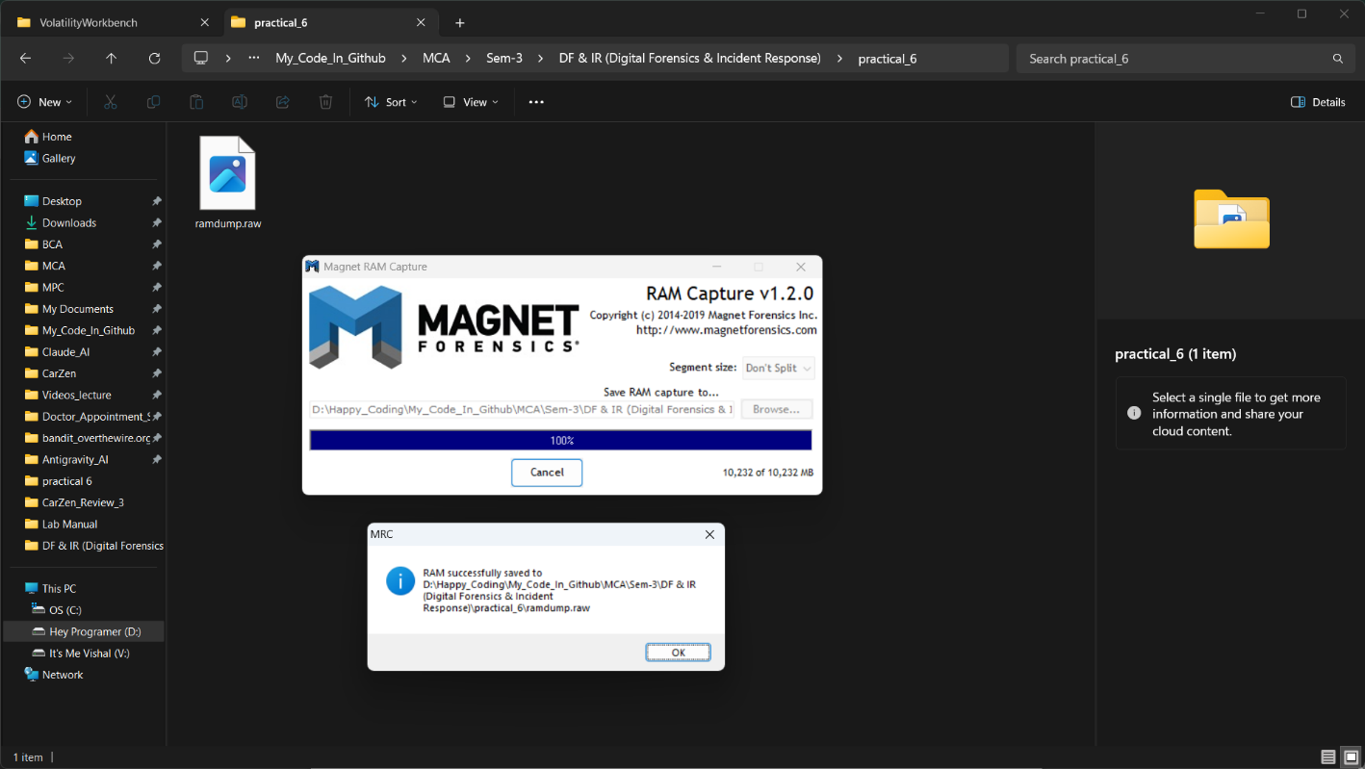
Figure 1: Successful RAM acquisition using Magnet RAM Capture v1.2.0, showing 100% completion and the saved ramdump.raw file.
POC Explanation:
The successful completion of Magnet RAM Capture confirms that the system's volatile memory was acquired and saved as ramdump.raw. The captured memory image, approximately 10,232 MB in size, was used as the input for further analysis with Volatility 3. Preserving RAM allows investigators to examine running processes and other memory artefacts that may be lost when the system shuts down.

Step 2: Load the Memory Image and Examine Running Processes
PassMark Volatility Workbench 3.0 (Build 1017), using Volatility 3 Framework 2.28.2, was used to examine the acquired memory image.
- Open Volatility Workbench.
- Load the captured ramdump.raw memory image.
- Select the Windows platform.
- Run the process-list command to enumerate processes recovered from the memory image.
- Examine the output, including process IDs, parent process IDs, process names, creation times, and other available details.
The process enumeration displayed Windows processes such as System, Registry, smss.exe, csrss.exe, wininit.exe, services.exe, and svchost.exe.
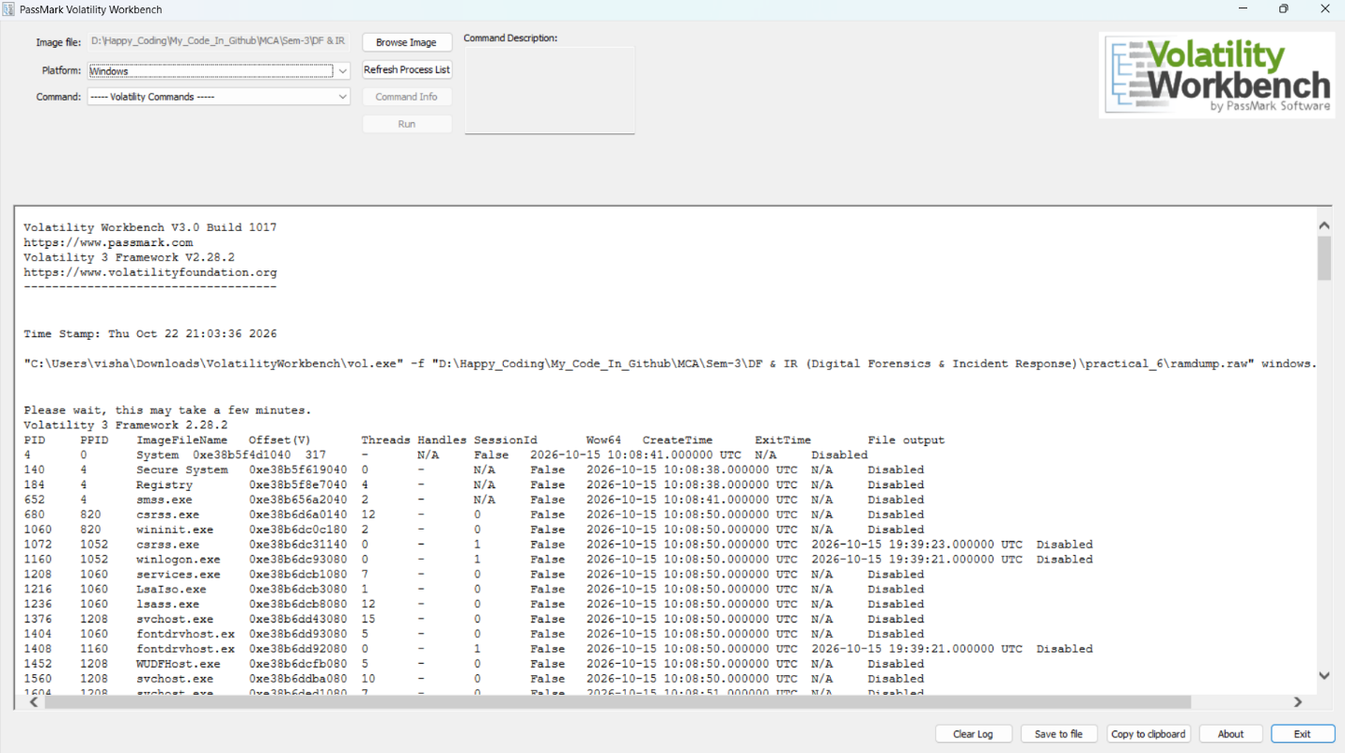
Figure 2: Initial Windows process enumeration from ramdump.raw using Volatility Workbench.
POC Explanation:
The process-list output demonstrates that Volatility 3 can recover process-related information from a Windows memory image. Process names and associated metadata help an examiner understand which applications and operating-system components were present when memory was captured. This information provides a starting point for investigating unusual processes and their relationships.

Step 3: Analyse the Windows Process Tree
The windows.pstree.PsTree plugin was executed to display processes in a hierarchical structure based on their parent process IDs.
- Open the Command dropdown in Volatility Workbench.
- Select windows.pstree.PsTree.
- Leave the Display physical offsets option unchecked.
- Leave the Process ID filter unchecked to display the available process tree.
- Click Run and examine the process hierarchy.
The process-tree output displayed Windows processes including System, smss.exe, csrss.exe, wininit.exe, services.exe, svchost.exe, winlogon.exe, and taskhostw.exe. The output also included WMIRegistration and child processes named mofcomp.exe.
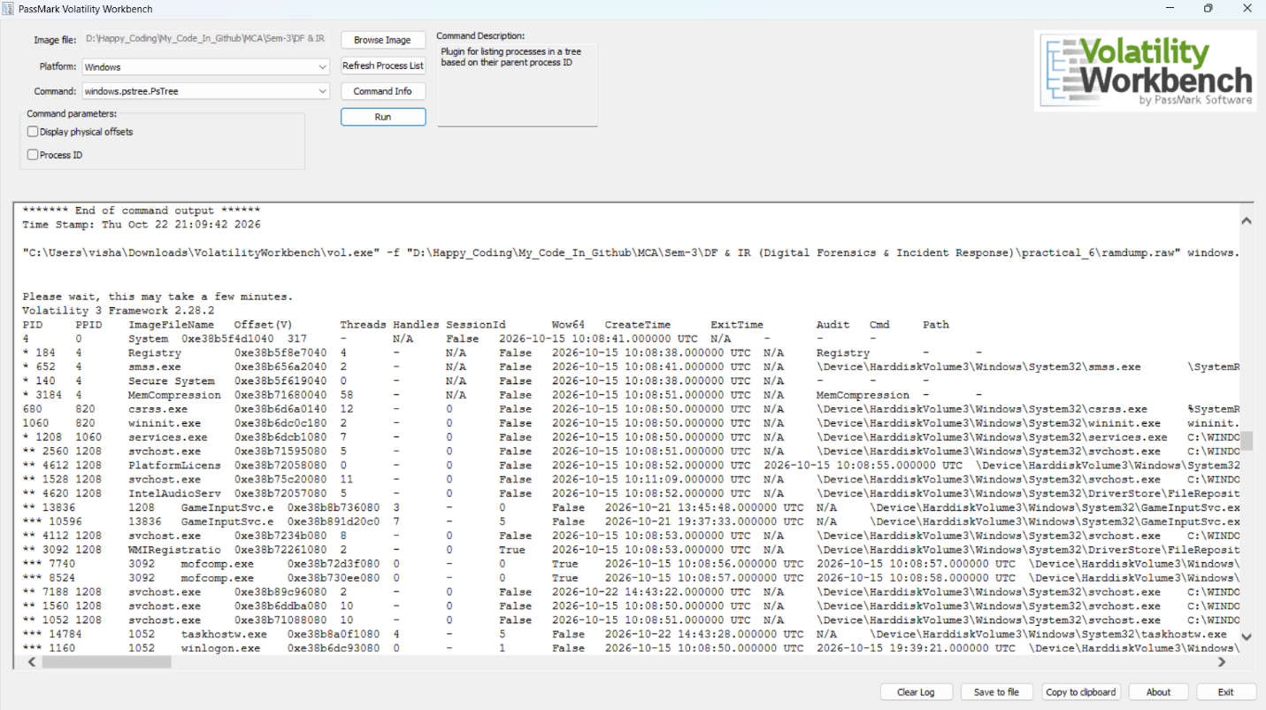
Figure 3: Windows process hierarchy generated using the Volatility 3 windows.pstree.PsTree plugin.
POC Explanation:
A process tree helps an examiner understand the parent-child relationships between processes. Unexpected parent-child relationships, unusual executable paths, and processes running from suspicious locations can provide leads for further investigation.
The appearance of mofcomp.exe in the process tree is an observation that may warrant additional context. However, its presence alone does not establish malicious activity. Process names, parent processes, executable paths, timestamps, and supporting evidence should be considered together before drawing conclusions.
Step 4: Examine Network Connection Artefacts
The windows.netscan.NetScan plugin was executed to search the memory image for recoverable network objects and connection information.
- Open the Command dropdown in Volatility Workbench.
- Select windows.netscan.NetScan.
- Leave the optional Include Corrupt parameter unchecked.
- Click Run and wait for the analysis to finish.
- Examine the output table for network details, including protocol, local address and port, foreign address and port, connection state, PID, and owner.
Result:
The plugin completed its execution, but the final network results table contained no connection entries.
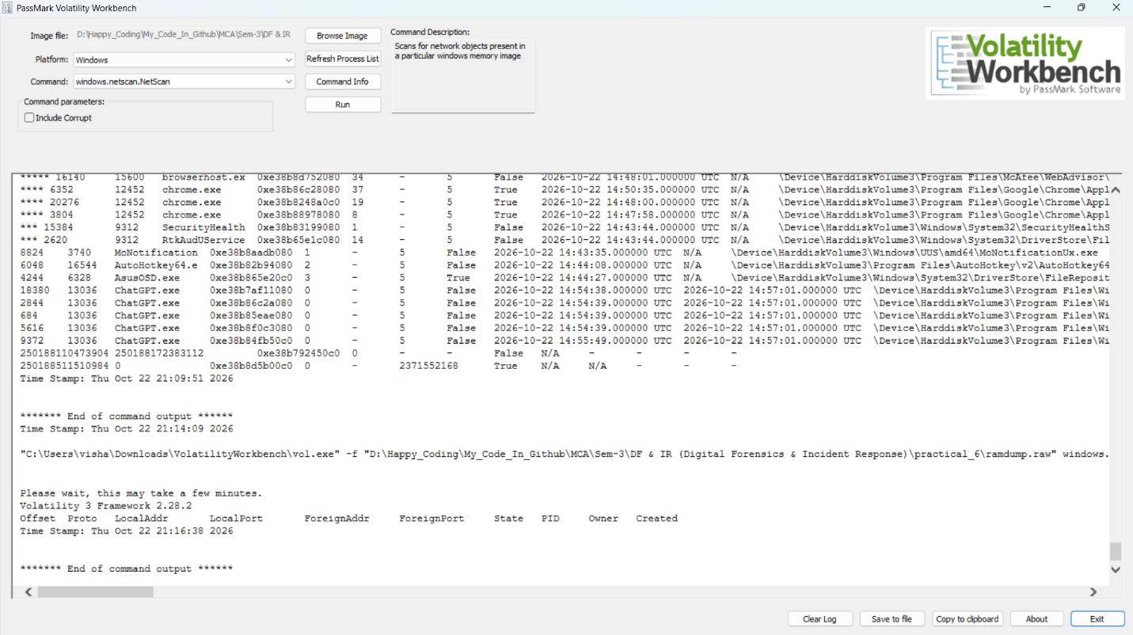
Figure 4: Volatility 3 windows.netscan.NetScan output showing an empty network results table for the analysed memory image.
POC Explanation:
The windows.netscan.NetScan plugin searches a Windows memory image for network objects that can be recovered by the analysis framework. When connection entries are recovered, their addresses, ports, states, and associated process information can help an examiner investigate network activity.
In this analysis, no network connection entries were displayed in the final results table. This means that the scan did not recover any entries for presentation. It does not, by itself, prove that the system had no network activity.

Step 5: Analyze Windows Processes Using PsList
The windows.pslist.PsList plugin in Volatility Workbench was used to examine the processes present in the captured memory image.
- Select the windows.pslist.PsList command in Volatility Workbench.
- Click Run to display the process list.
- Examine the process names, process IDs (PID), parent process IDs (PPID), and other available details.
- Identify the mofcomp.exe processes in the results.
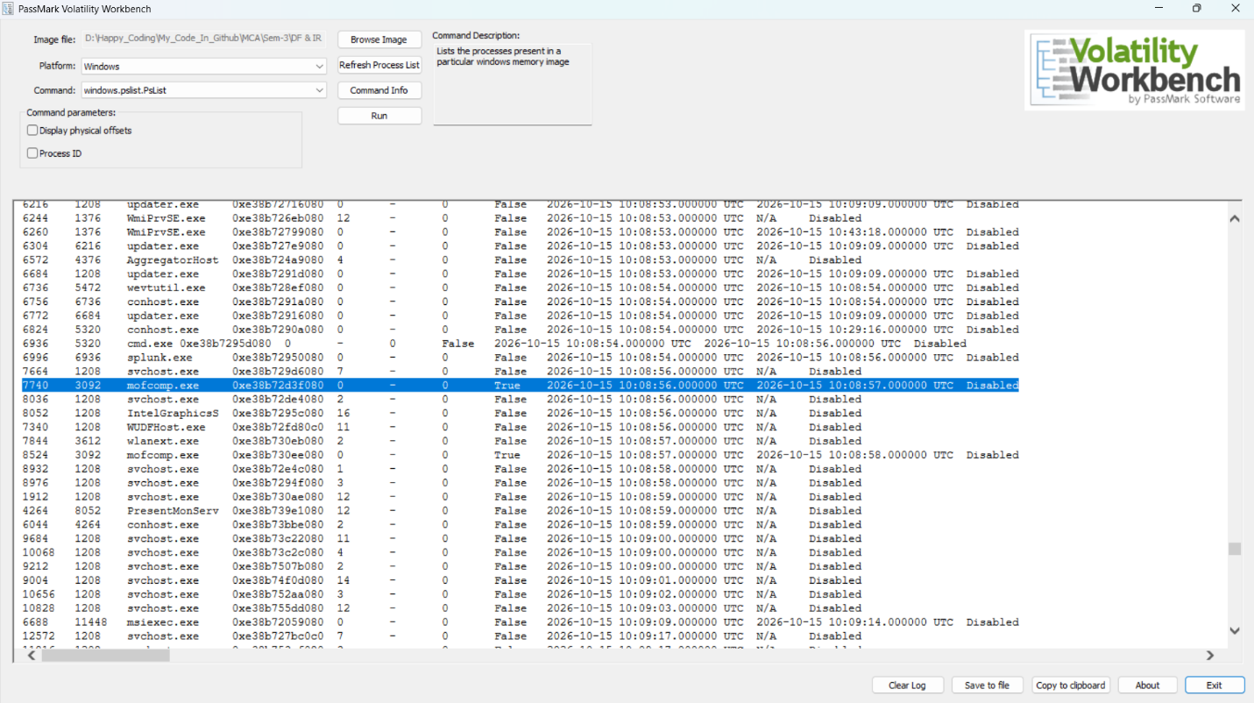
Figure 5: Volatility Workbench displaying the Windows process list, including mofcomp.exe and its associated process information.
POC Explanation
The windows.pslist.PsList plugin lists processes identified in the memory image. Process details, including PID and PPID, help investigators examine process relationships and identify entries that may require further investigation.

Step 6: Extract and Analyze Memory Strings
The Sysinternals Strings utility was used to extract readable text from the captured memory image (ramdump.raw) and save the output in memory_strings.txt.
- Open PowerShell in the directory containing ramdump.raw.
- Run the Strings utility to extract readable strings from the memory dump.
- Save the output to memory_strings.txt.
- Search the extracted text for process names, URLs, and potentially suspicious indicators.
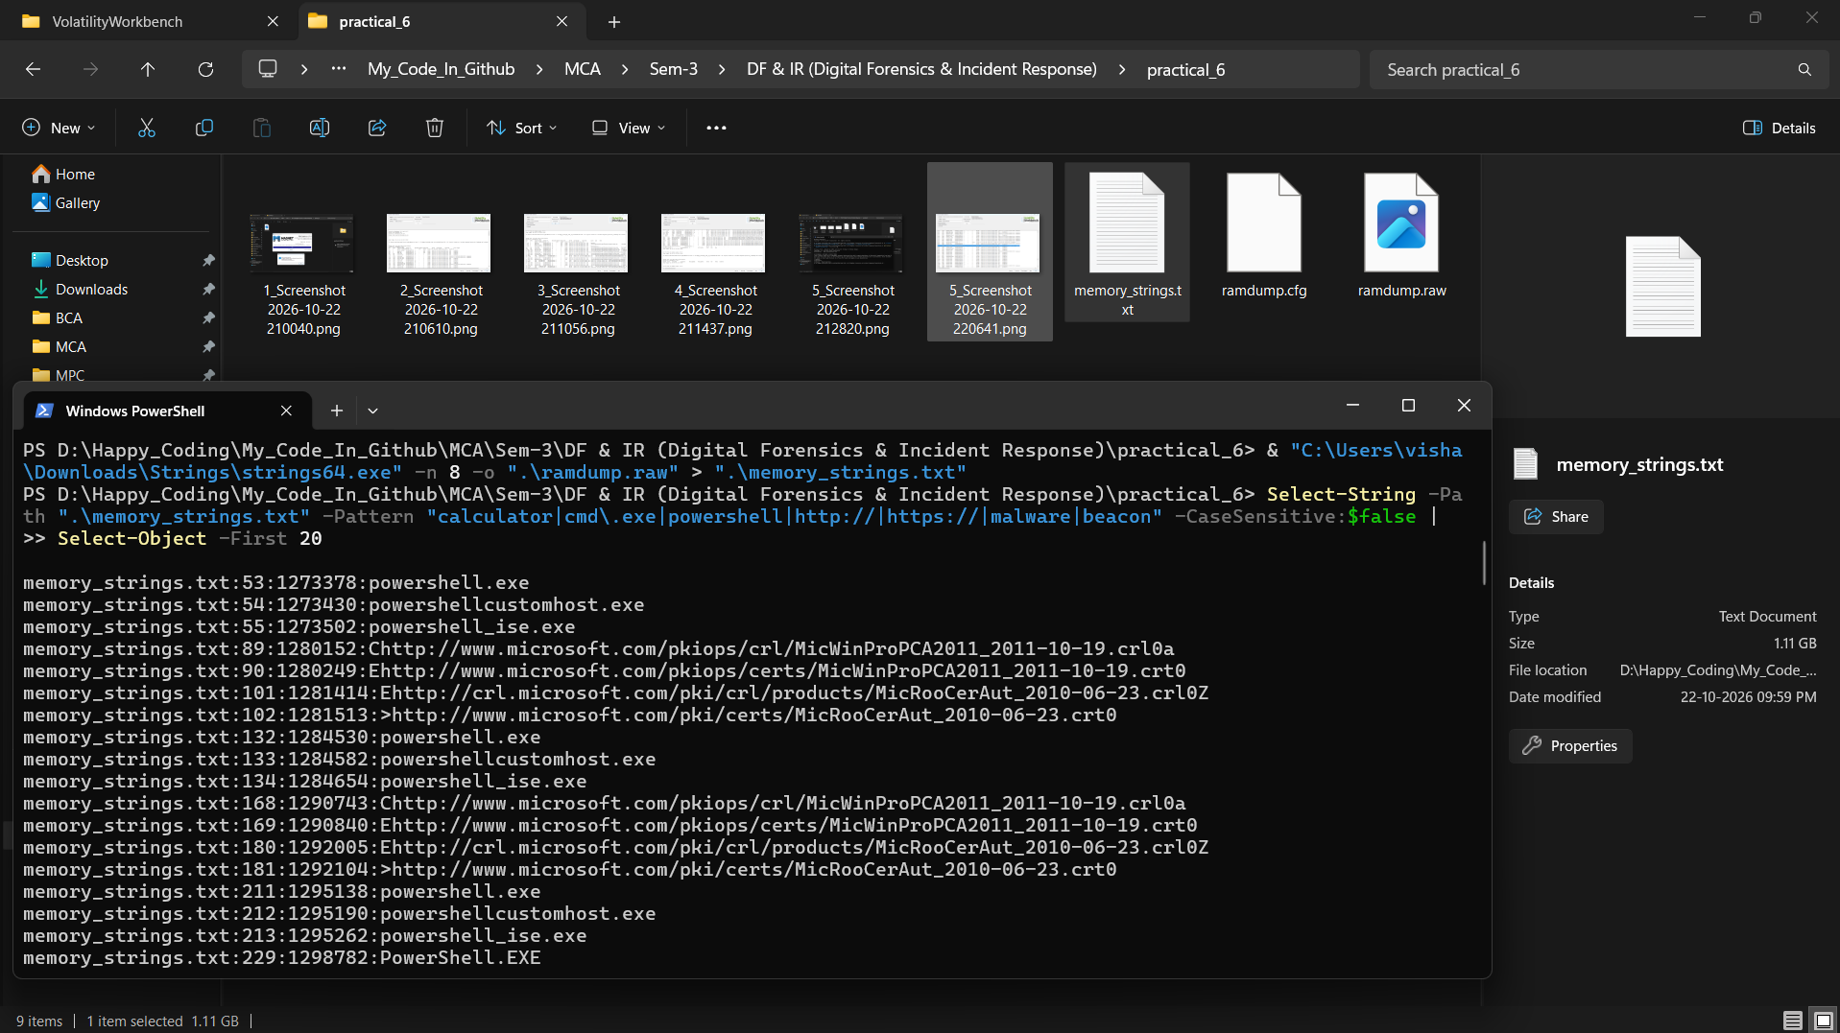
Figure 6: PowerShell displaying the search results from the extracted memory strings.
POC Explanation
The extracted strings included PowerShell-related text, a Windows Calculator package identifier, Microsoft certificate URLs, and other website URLs. No confirmed malware indicators were identified in the available results. Since the extraction was interrupted, the results represent only a partial analysis.

Conclusion
Memory forensics was performed using Magnet RAM Capture, Volatility Workbench, and the Sysinternals Strings utility. The captured RAM image was analyzed to examine running processes, process relationships, network artefacts, and readable memory strings. Although some potentially relevant artefacts were identified, the analysis did not confirm malware infection. The practical demonstrated how memory forensics can support the investigation of system activity and potential security incidents.

Observation
- RAM was successfully captured using Magnet RAM Capture.
- The memory image was saved as ramdump.raw.
- Volatility 3 was used to examine Windows processes.
- The process tree displayed parent-child relationships, including mofcomp.exe.
- NetScan did not recover any network connection entries.
- Memory string analysis revealed system-related text and website URLs.
- No malware infection was confirmed from the available results.

TryHackMe Room - Memory Analysis Introduction


